Task 1
Сайт Дарвиновского музея: http://www.darwinmuseum.ru
Виртуальный тур по Дарвиновскому музею: https://clck.ru/N6sjH

Read the text and fill in the gaps (A–F) with the statements (1–7). There is one extra statement.
The history of natural science
Man has long sought to understand the nature of the surrounding living beings, A_____________________. The way from the first rock carvings of animals to the scientific picture of the world was long and arduous. The history of biology knows the periods of the surge of interest in wildlife, B___________________.
The founder of biology as a science believe the ancient Greek scholar Aristotle
(385–322 BC). During the Renaissance (XIV–XVIII) C__________________: anatomy, physiology, embryology, zoology, paleontology. Information about extinct animals and plants, the similarities in the structure of the different groups of living beings D_____________________. The first evolutionary theory began to emerge in the late XVIII – early XIX centuries, the most coherent and consistent was the theory of J.-B. Lamarck (1744–1829). The first truly scientific theory explaining the diversity of living organisms, belongs to Charles Darwin
(1809– 1882). At the intersection of Darwinism and genetics the synthetic theory of evolution was born, it E___________________.
Since ancient times man tried to explain the reasons for F__________________.
The biological roots of knowledge goes back to antiquity. Judging by the rock paintings, more than 15 thousand years ago people could distinguish a lot of animals.

1. Continues its development to this day.
2. Get the development under the influence of religion.
3. The huge diversity of living organisms around him.
4. Have guided scientists to think about the historical development of the organic world.
5. And times of stagnation in research ideas.
6. As we can judge from extant rock paintings.
7. Certain branches of biology get the development.

Today you are going to take a tour of the history of the natural sciences exposition in The State Darwin Museum. You will have to complete different tasks. In conclusion, you will write a letter according to the information, which you have studied during the lesson. For unfamiliar words you may consult the Glossary list on the last page of your worksheet. Look at the map of the museum. Where is the hall “The History of the Natural Sciences” situated?
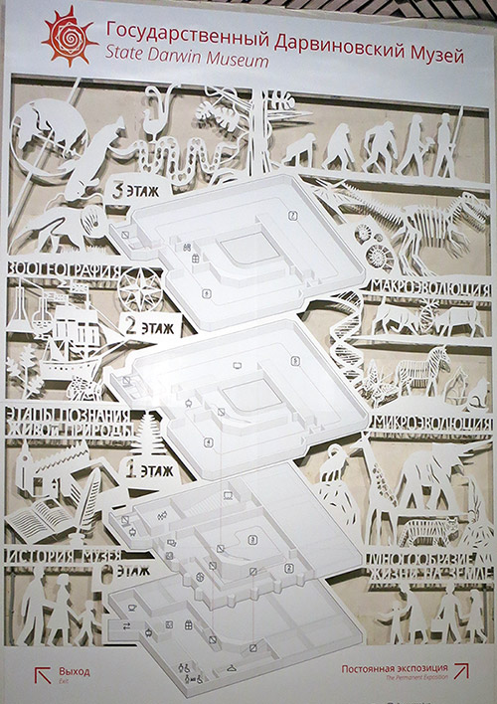
Using the information from the text in task 1 write what aspects of the history of the natural sciences we are going to study in this hall.
________________________________________________________________________________________________________________________________________________________________________________________________________________________________________________________________________________

Task 2
Use a virtual tour the museum: https://clck.ru/SezJJ

Look at the paintings above the arch. How do we call them?
What information can scientists get studying them?
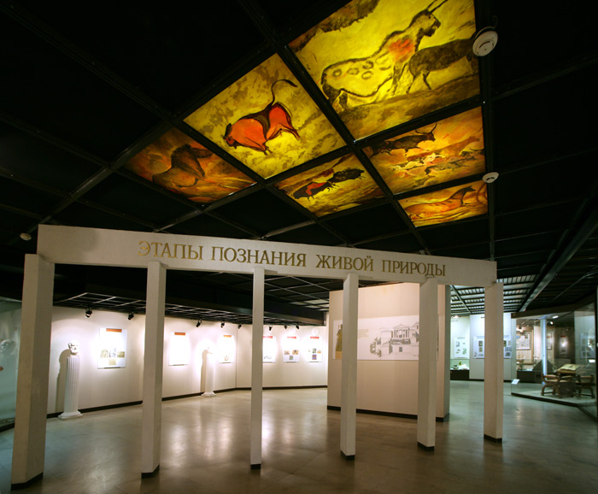
________________________________________________________________________________________________________________________________________________________________________________________________________________________________________________________________________________

Task 3
Use a virtual tour the museum: https://clck.ru/SezJJ
Early forms of religions reflect ancient people’s knowledge of the environment. Find a poster “Early forms of religions” and answer the questions.
- What name does one of the eight Seneca Indian tribes have?
____________________________________________________________________
- Why were statuettes depicting spirits made?
____________________________________________________________________
- Where do people organize annual bear feasts?
____________________________________________________________________
- What were the main functions of shaman?
____________________________________________________________________
Task 4
Use a virtual tour the museum: https://clck.ru/SezNi
In the ancient world some animals were sacred. Match the animals with the countries where they were sacred.
a cat a heron 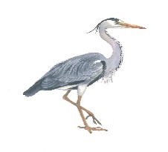
a cock 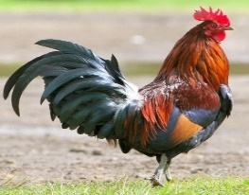 a scarab 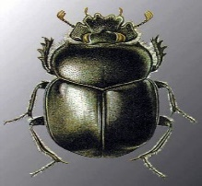
a cobra 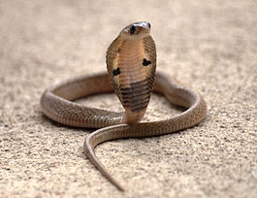
Countries | Animals
Ancient Egypt
Ancient India

Task 5
Aristotle is known as the inventor of biology. Read the text about Aristotle’s biology and decide if the statements are true (T) or false (F).
Aristotle's biology is the theory of biology, grounded in systematic observation and collection of data, mainly zoological, embodied in Aristotle's books on the science. Many of his observations were made during his stay on the island of Lesbos, including especially his descriptions of the marine biology of the Pyrrha lagoon, now the Gulf of Kalloni. His theory is based on his concept of form, which derives from but is markedly unlike Plato's theory of Forms.
The theory describes five major biological processes, namely metabolism, temperature regulation, information processing, embryogenesis, and inheritance. Each was defined in some detail, in some cases sufficient to enable modern biologists to create mathematical models of the mechanisms described. Aristotle's method resembled the style of science used by modern biologists when exploring a new area, with systematic data collection, discovery of patterns, and inference of possible causal explanations from these. He did not perform experiments in the modern sense, but made observations of living animals and carried out dissections. He named 500 species of birds, mammals and fish; and he distinguishes dozens of insects and other invertebrates. He described the internal anatomy of over a hundred animals, and dissected around 35 of them.
- Aristotle made observations during his stay on the island Rhodes.
- Pyrrha lagoon remains its name nowadays.
- Aristotle’s theory derives from Plato’s theory of Forms.
- In some cases modern biologists have sufficient information to create mathematical models of the mechanisms described in the Aristotle’s theory.
- Aristotle named over a thousand species of birds, mammals and fish.
Task 6
Use a virtual tour the museum: https://clck.ru/Sf2T8
Find the room of the alchemist. Match the following objects with their definitions. Find these objects in the room.
A –…, B – …, C –…, D –…, E –…, F –…
- Alchemist | - A container for ink, used in the past that fitted into a hole in a table
- Flask | - A device used for picking up objects, consisting of two long pieces joined at one end and pressed together at the other end in order to hold an object between them
- Inkwell | - A heavy block of iron on which heated pieces of metal are made into a particular shape with a hammer
- Tongs | - A device used for distillation or dry distillation of substances
- Anvil | - A scientist in the Middle Ages, that was trying to find a way to change ordinary metals into gold
- Retort | - A glass container for liquids with a wide base and a narrow neck, used in scientific work
Task 7
The Renaissance is known for a rise of science. Several branches of biology appeared: physiology, embryology, systematics, paleontology, comparative anatomy. The developing of microscopes helped scientists to explore the world of microorganisms. Compare the pictures of microscopes with their models in case.
Match the microscopes with their names in the table.
- 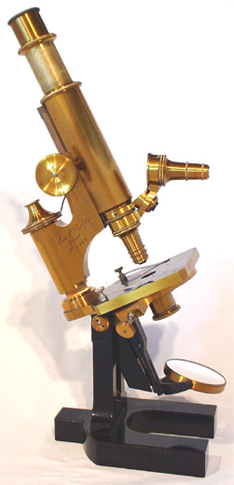 | - A. Leeuwenhoek's microscope
- 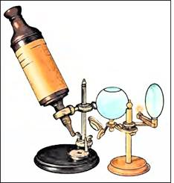 | - Flea glass
 | - R. Hooke’s microscope
- 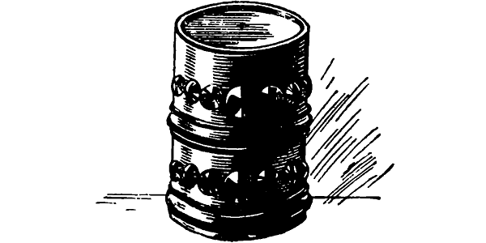 | - K. Zeiss microscope
- – … 2) – … 3) – … 4) – …

Task 8
In 1809 Jean-Baptiste Lamarck invented the first theory of evolution.
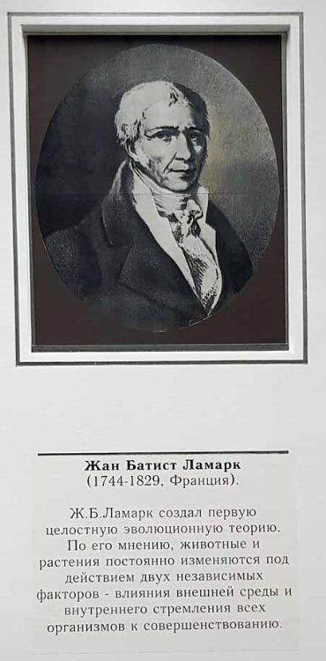
Read the statements and decide if they are true (T) or false (F).
Jean-Baptiste Lamarck set up the following principles:
- The inner tendency of organisms to progress.
- The ability of organisms to adapt to the environment.
- The organisms do not transfer their abilities hereditarily.
- The environment doesn’t affect the organisms.
- Inheritance.
Task 9
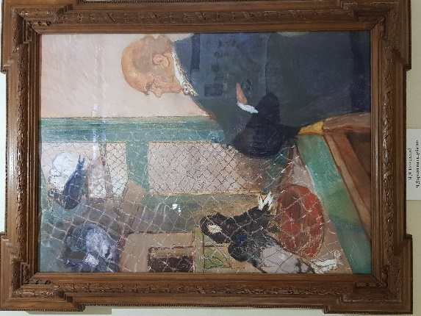
Take a look at the picture and answer the questions.
What birds did Charles Darwin study to prove his theory?
__________________________________
What conclusions did he draw?
__________________________________
__________________________________
Task 10
Use a collection of elements in the lesson description: «Сравнение Дарвиновской и синтетической теорий эволюции».

Read the text. Fill in the gaps with the right forms of the words written in capitalized letters.
What is evolution?
The theory of evolution is a (1) __________ SCIENCE theory that essentially states that species change over time. There are many different ways species change, but (2) __________ MANY of them can be described by the idea of natural selection. The theory of evolution through natural selection was (3) _________ ONE scientific theory that put together evidence of change through time as well as a mechanism for how it happens.
Sometimes called “survival of (4) ________ FIT,” natural selection was most famously explained by Charles Darwin in his book “On the Origin of Species”.
In the book, Darwin (5) ________ PROPOSE that individuals with traits most suitable to their environments lived long enough to reproduce and passed down those desirable traits to their offspring. If an individual had less than favorable traits, they (6) __________ DIE and not pass on those traits. Over time, only the “fittest” traits of the species survived. Eventually, after enough time passed, these small adaptations would add up to create new species. These changes are precisely what makes us human.
Task 11
In 20th century the modern synthesis was set. This theory integrated Darwinian theory and genetics. Take a look at these definitions and fill in the table, matching each definition with a proper column.
- the unit of evolution is the organism;
- the unit of evolution is the population;
- the species is the artificial conception. There are no differences between species and variety;
- the species is genetically comprehensive and closed system protected from interspecific crossing;
- speciation is stimulated by a large fertility and wide settlement of species in nature. This enlarges the chances of favorable changes;
- speciation happens as a result of accumulation of differences between populations.
The modern synthesis | Darwinian theory

Task 12
You have received a letter from your English-speaking pen-friend Tom who writes:
Last month my parents and I went to the Natural History Museum in London.
The museum is home to life and earth science specimens comprising some 80 million items within five main collections: botany, entomology, mineralogy, paleontology and zoology. Given the age of the institution, many of the collections have great historical as well as scientific value, such as specimens collected by Charles Darwin. Have you ever been to The State Darwin Museum in Moscow? What facts about the development of natural sciences have you learned there?
Do you have the statue to Darwin in Moscow?
After visiting the Natural History Museum I got an interesting project. I wrote a paper about interesting facts in Darwin’s life…
Write a letter to Tom.
In your letter:
– answer his questions;
– ask 3 questions about his project paper.
Write 100–140 words.
Remember the rules of letter writing.
________________________________________________________________________________________________________________________________________________________________________________________________________________________________________________________________________________________________________________________________________________________________________________________________________________________________________________________________________________________________________________________________________________________________________________________________________________________________________________________________________________________________________________________________________________________________________________________________________________________________________________

GLOSSARY

Study the words and their definitions

Diversity, n – a situation in which many different types of things or people are included in something.

Extant, adj –used to refer to something very old that is still existing.

Arduous, adj – difficult, needing a lot of effort and energy.

Coherent, adj – If an argument, set of ideas, or a plan is coherent, it is clear and carefully considered, and each part of it connects or follows in a natural or reasonable way.

Consistent, adj – agreeing with something said or done previously.

Embody, v – to have and show particular qualities or ideas; represent.

Marked, adj – obvious or noticeable.

Sufficient, adj – enough for a particular purpose.

Resemble, v – to look like or be like someone or something.

Pattern, n – something that is used as an example, especially to copy.

Dissection, n – the action of cutting something open, especially a dead body or plant, in order to study its structure.

Invertebrate, n – an animal with no spine.

Flask, n – a glass container for liquids with a wide base and a narrow neck, used in scientific work.

Tongs, n – a device used for picking up objects, consisting of two long pieces joined at one end and pressed together at the other end in order to hold an object between them.

Retort, n – a device used for distillation or dry distillation of substances.

Hereditary, adj – (of characteristics or diseases) passed from the genes of a parent to a child, or (of titles and positions in society) passed from parent to a child as a right.

Inheritance, n – a physical or mental characteristic inherited from your parents, or the process by which this happens.

Trait, n – a particular characteristic that can produce a particular type of behavior.

Offspring, n – the young of an animal, or a person’s children.

Precisely, adv – exactly.

Exquisite, adj – very beautiful and delicate.
Recapitulate, v – to repeat the main points of an explanation or description.

